How I migrated applications from Elasticbeanstalk to eks using aws secret manager and helm.

This documentation is about tools, services and methodology which I used to migrate an application from Elastic Beanstalk to Elastic Kubernetes in Amazon Web Services.
We have few application which are running in Elasticbeanstalk and we were needed it to migrate to EKS since the applications were already containerized and due to the eaziyness in maintaining the application in eks comparing to beanstalk.

What is current setup with eks?
* Sealed secrets
* CI with jenkins pipelines and github actions
* Gitops with ArgoCD

Cons of sealed secrets:
* Sealed secrets are not rotated and difficult to maintaining
* Need kubeseal to encrypt secrets and it creates issues with cluster certificates sometime.
* Security risk in keepting the secrets in git repositories

What is the approached solution?
AWS secret manager and external secret operator to consume the secret to eks cluster.
* Supports eks and fargate clusters
* Secret rotation control by AWS secret manager (external secret operator is compatible with multiple secret providers)

How external secret operator works?
Unlike sealed secrets, external secrets get secrets from external secret stores. Here we have aws secret manager as store and operator fetches secrets to cluster and stores it as native kubenrtes secrets.

What do we need to configure?
Secretstore: It is a namespaced object and its used to define the external secrets store and authentication mechanism to access the declared store.
ClusterSecretStore: Its same as secretstore, but defines cluster-wide Secretstore
ExternalSecret: It defines secret data to fetch from SecretStore and how to store it in K8S native secrets
ClusterExternalSecret: Its same as ExternalSecret but can push secrets to multiple namespaces using selectors.

In our case we only used SecretStore and ExternalSecret for application since the secrets were namespace scoped.

How to implement?
We need to create needed secrets in AWS secret manager, and we created key value pairs .
Then the operator need to be deployed to the eks cluster.

helm install external-secrets external-secrets/external-secrets
n kube-system --create-namespace --set installCRDs=true

Once the operator installed we can verify the resources deployed into the cluster:

kubectl api-resurces –api-group=external-secrets.io

Above command will list the api resources of external secret operator which are available in the cluster.
Then we need to create a IAM service account with privilege to read secrets created in AWS Secret Manager. Once these are ready, we can proceed with preparation of application helm charts and adding the secrets to these helm charts. An example policy for service account:

{ "Version": "2012-10-17",
"Statement": [ { "Sid": "VisualEditor0", "Effect": "Allow", "Action": [
"secretsmanager:GetSecretValue",
"secretsmanager:DescribeSecret",
"secretsmanager:GetResourcePolicy",
"secretsmanager:ListSecretVersionIds"
],
"Resource": "arn:aws:secretsmanager:<REGION>:<ACCOUNTNUM>:secret:prod/blogdemo/mysql1-Ft6k18" } ] }

Create secret store:
We need to create a secret store which targets aws secret manager and it contains service account to authenticate aws.

apiVersion: external-secrets.io/v1beta1
kind: SecretStore
metadata:
name: secret-store
namespace: demo-namespace
spec:
provider:
aws:
service: SecretsManager
region: us-east-1
auth:
jwt:
serviceAccountRef:
name: blogdemo-sa

and we can verify the secretstore as follows:
kubectl get secretstore

Create ExternalSecret:
Create an ExternalSecret resource which contains the info of the secret you want to fetch and store it as a native k8s secret inside the cluster.

apiVersion: external-secrets.io/v1beta1
kind: ExternalSecret
metadata:
name: blogdemo-secret
namespace: demo-namespace
spec:
refreshInterval: 1m #how oftensecret data to be refreshed
secretStoreRef:
name: secret-store #name of secretstore created
kind: SecretStore
target:
name: blog-demo-secret #name of k8s secret to be created
data:
- secretKey: demo-username #key in target secret set above, to be used in pod
remoteRef:
key: demo-remote-secret #aws secret manager secret name
property: username #aws secret manager secret key
- secretKey: demo-password #key in target secret set above, to be used in pod
remoteRef:
key: demo-remote-secret #aws secret manager secret name
property: password #aws secret manager secret key

Verify the resources created using kubectl cli.

Kubectl get externalsecret
kubectl get secret/blog-demo-secret

To create the helm chart for application we can use the command:
$ helm create <chart name>

Once this command ran, it will create a helm chart with its basic folder and file structure. Which contains,
- charts
- templates
- chart.yaml
- values.yaml

We need to edit the values.yaml file according to our appliation. Please note below images contains some random values, it need to be changed according to the application.

1. Update image values.

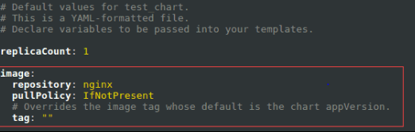

2. Change image pull policy
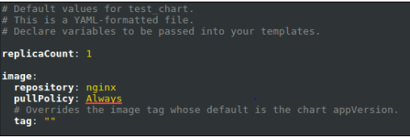

3. Update the helm chart nameoverride if you want
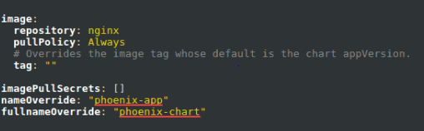

4. Specify service account name and details. Please note since the service account is already created we need to set create=false instead true as showing in the image
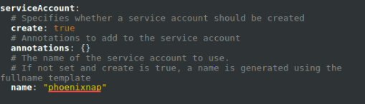

So as per our application it will be as below:
serviceAccount:
create: false
annotations: {}
name: blog-demo-sa

Then we need to update template files details to match with your application name and its metadata. Together with that we need to add two more files in template directory to consume external secrets in the helm chart.

SecretStore.yaml:

{{- if .Values.externalSecrets.enabled }}
apiVersion: external-secrets.io/v1beta1
kind: SecretStore
metadata:
name: {{ include "yourchartname.fullname" . }}-secretStore
labels:
{{- include "yourchartname.labels" . | nindent 4 }}
spec:
provider:
aws:
service: SecretsManager
region: {{ .Values.externalSecrets.awsRegion }}
auth:
jwt:
serviceAccountRef:
name: {{ .Values.externalSecrets.serviceAccount }}
{{- end }}

ExternalSecret.yaml:

{{- if .Values.externalSecrets.enabled }}
{{- $fullName := include "yourchartname.fullname" . -}}
{{- $labels := include "yourchartname.labels" . -}}
{{- range $externalSecrets := .Values.externalSecrets.secrets -}}
---
apiVersion: external-secrets.io/v1beta1
kind: ExternalSecret
metadata:
name: {{ $fullName }}-externalsecret-{{ $externalSecrets.externalSecretName }}
labels:
{{ $labels | nindent 4 }}
spec:
refreshInterval: {{ $externalSecrets.secretRefreshInterval }}
secretStoreRef:
name: {{ $fullName }}-secretStore
kind: SecretStore
target:
name: {{ $externalSecrets.targetSecretName }}
data:
{{- range $externalSecrets.secretData }}
- secretKey: {{ .targetSecretKey }}
remoteRef:
key: {{ $externalSecrets.awsSecretsManagerSecretName }}
property: {{ .remoteSecretKey }}
{{- end }}
{{ end }}
{{- end }}

Then we can add external secret block in values.yaml. An example is as below:
externalSecrets:
enabled: true
awsRegion: eu-central-1
serviceAccount: eso-secrets-sa # service account to access your secrets
secrets:
- externalSecretName: appexternalsecret # Name for externalSecret resource
secretRefreshInterval: 1h # secret's refresh interval
awsSecretsManagerSecretName: eso-remote-secret # name of secret on AWS Secrets Manager
targetSecretName: eso-local-secret # name of secret that will be created on k8s
secretData:
- remoteSecretKey: aws-username # Key of your secret on AWS Secret Manager
targetSecretKey: k8s-username # Matching Key to be created for the matching local secret on k8s
- remoteSecretKey: aws-password
targetSecretKey: k8s-password

So now we have the secrets added in values file. Next is to mount the secrets using deployment.yaml . Since I needed the secret as env variables in the applications, added below lines under containers directive of deployment.yaml file:

env:
{{- with .Values.secretEnv }}
{{- toYaml . | nindent 12 }}
{{- end }}

Once the helm chart is ready I pushed the same to git repository and deployed the same using our gitOps pipeline.

